# AIM

COMPARITIVE STUDY AND QUALITATIVE ANALYSIS OF DIFFERENT BRANDS OF COLD DRINKS

# PURPOSE

In recent days, soft drink brands were put into various questions regarding their purity. News flashed that they contain harmful pesticide, which arouse many interest in knowing its contents because I have been drinking them for years. I wanted to confirm that whether the charge impose on these brands are true or not.

Another fact which inspired me to do this project is that I am in touch with qualitative analysis whose knowledge with other factors helped me to do so.

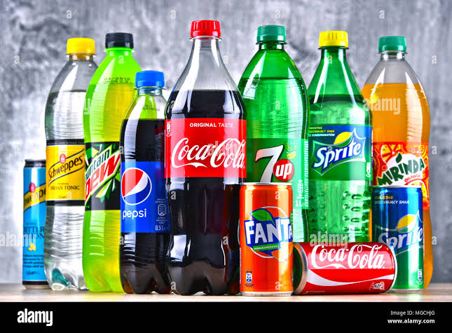

# CONTENTS

* Introduction
* Theory
* Apparatus
* Chemicals required
* Detection of pH
* Test for Carbon Dioxide
* Test for Glucose
* Test for Phosphate
* Test for Alcohol
* Test for Sucrose
* Result
* Conclusion

# INTRODUCTION

The era of cold drinks began in 1952 but the indianization of industry marked its beginning with launching of limca and goldspot by parley group of companies. Since, the beginning of cold drinks was highly profitable and luring, many multinational companies launched their brands in India like pepsi and coke.

Now days, it is observed in general that majority of people viewed Sprite, Miranda, and Limca to give feeling of lightness, while Pepsi and Thumps Up to activate pulse and brain.

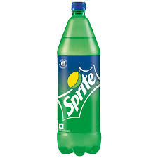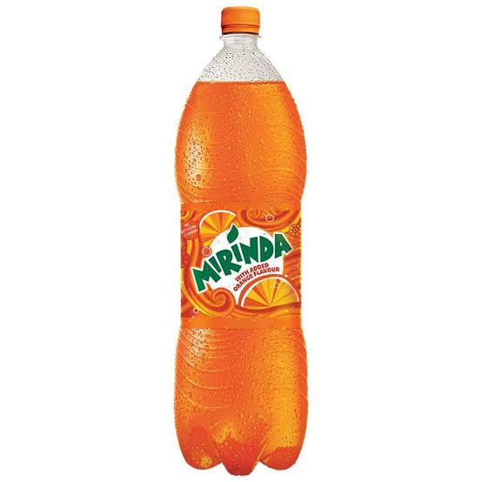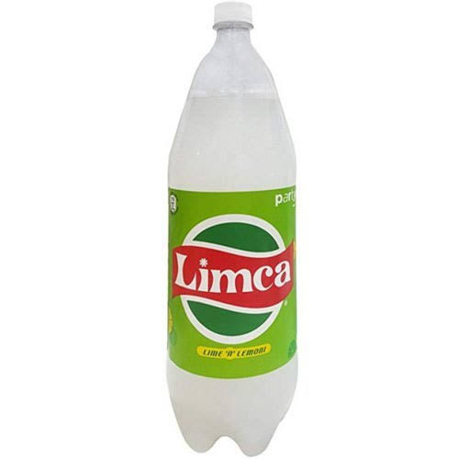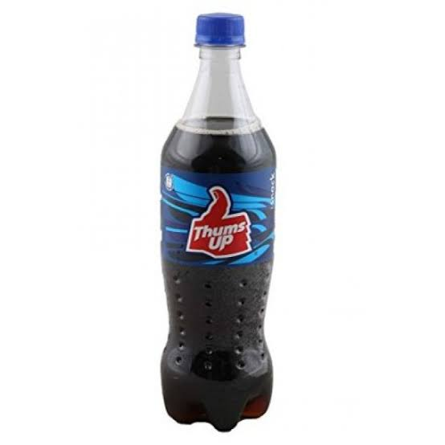

# THEORY

Cold drinks of different brands are composed of alcohol, carbohydrates, carbon dioxide, phosphate ions etc. These soft drinks give feeling of warmth, lightness and have a tangy taste which is liked by everyone. Carbon dioxide is responsible for the formation of froth on shaking the bottle.

The carbon dioxide gas is dissolved in water to form carbonic acid which is also responsible for the tangy taste. Carbohydrates are the naturally occurring organic compounds and are major source of energy to our body. General formula of carbohydrates is

CX (H2O)Y.

Cold drinks are a bit acidic in nature and their acidity can be measured by finding their pH value. The pH values also depend upon the acidic contents such as citric acid and phosphoric acid.

# APPARATUS

* Test tube
* Test tube holder
* Test tube stand
* Stop watch
* Beaker
* Burner
* pH paper tripod stand
* China dish
* Wire gauge
* Water bath

**CHEMICALS REQUIRED**

* Iodine solution
* Potassium iodine
* Sodium hydroxide
* Fehling’s A & B solution
* Lime water
* Concentrated HNO3
* Benedict solution
* Ammonium molybdate

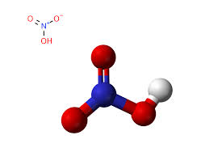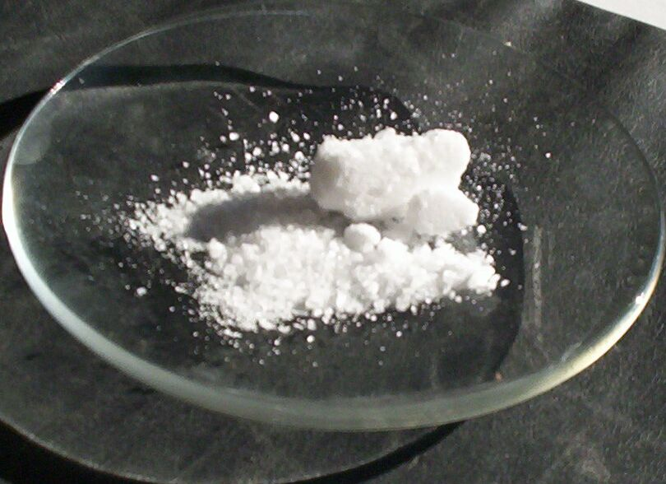

**DETECTION OF PH**

1-2 drops of the sample of cold drink of each brand was taken and put on the pH paper. The change in the color of pH paper was noticed and was compared with the standard pH scale.

|  |  |  |  |
| --- | --- | --- | --- |
| **SERIAL**  **NO** | **NAME OF**  **DRINK** | **COLOUR**  **CHANGE** | **PH VALUE** |
| 1 | COCA COLA | PINK | 1-2 |
| 2 | SPRITE | ORANGE | 3 |
| 3 | LIMCA | PINKISH | 3-4 |
| 4 | FANTA | LIGHT PINK | 2-3 |

**OBSERVATION**

**INFERENCE**

Soft drinks are generally acidic because of the presence of citric acid and phosphoric acid. pH values of cold drink of different brands are different due to the variation in amount of acidic contents.

## TEST FOR CARBON DIOXIDE

**EXPERIMENT**

As soon as the bottles were opened, one by one the sample was passed through lime water. The lime water turned milky.

**OBSERVATON**

|  |  |  |  |
| --- | --- | --- | --- |
| **SR. NO** | **NAME OF THE DRINK** | **TIME TAKEN (SEC.)** | **CONCLUSION** |
| 1 | COCA COLA | 26.5 | CO2 IS PRESENT |
| 2 | SPRITE | 21 | CO2 IS PRESENT |
| 3 | LIMCA | 35 | CO2 IS PRESENT |
| 4 | FANTA | 36 | CO2 IS PRESENT |

**INFERENCE**

All the soft drinks contain dissolved carbon dioxide in water. The carbon dioxide (CO2) dissolves in water to form carbonic acid, which is responsible for its tangy taste.

**CHEMICAL REACTION INVOLVED**

Ca(OH)2 (s) + CO2(g) →CaCO3 (s) + H2O(s)

## TEST FOR GLUCOSE

Glucose is a reducing sugar acid. Its presence is detected by the following test:-

### BENIDICTS’S SOLUTION TEST:-

A small sample of cold drink of different brands was taken in a test tube and a few drops of Benedict’s reagent were added. The test tube was heated for few seconds. Formation of reddish color confirms the presence of glucose in cold drinks.

**OBSERVATON**

|  |  |  |  |
| --- | --- | --- | --- |
| **SR. NO** | **NAME OF THE DRINK** | **OBSERVATION (REDDISH COLOUR)** | **CONCLUSION** |
| 1 | COCA COLA | POSITIVE | GLUCOSE+ |
| 2 | SPRITE | POSITIVE | GLUCOSE+ |
| 3 | LIMCA | POSITIVE | GLUCOSE+ |
| 4 | FANTA | POSITIVE | GLUCOSE+ |

**INFERENCE**

All the samples gave positive test for glucose with Benedict’s reagent. Hence all the drinks contain glucose.

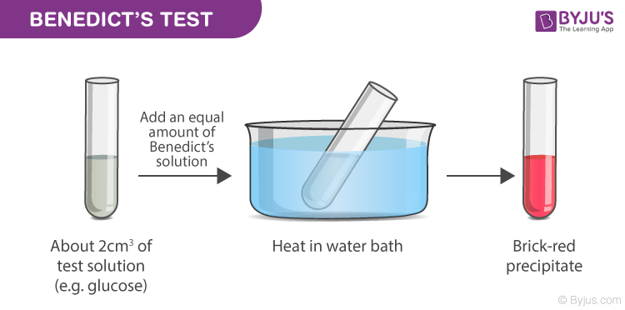

### FEHLING’S SOLUTION TEST

A small sample of cold drink of different brands was taken in a test tube and a few drops of Fehling’s A solution and Fehling’s B solution was added in equal amount. The test tube was heated in a water bath for 10 minutes. Appearance of brown precipitate confirms the presence of glucose in cold drinks.

**OBSERVATON**

|  |  |  |  |
| --- | --- | --- | --- |
| **SR. NO** | **NAME OF THE**  **DRINK** | **OBSERVATION** | **CONCLUSION** |
| 1 | COCA COLA | Reddish Brown Precipitate | GLUCOSE PRESENT |
| 2 | SPRITE | Reddish Brown Precipitate | GLUCOSE PRESENT |
| 3 | LIMCA | Reddish Brown Precipitate | GLUCOSE PRESENT |
| 4 | FANTA | Reddish Brown Precipitate | GLUCOSE PRESENT |

**INFERENCE**

All the samples give positive test for glucose with Fehling’s solutions (A&B).Hence all the cold drinks contain glucose.

## 

## TEST FOR PHOSPHATE

Sample of each brand of cold drink was taken in a separate test tube and ammonium molybdate followed by concentrated nitric acid (HNO3) was added to it, the solution was taken heated and the color of the precipitate confirms the presence of phosphate ions.

**OBSERVATON**

|  |  |  |  |
| --- | --- | --- | --- |
| **SR. NO** | **NAME OF THE DRINK** | **OBSERVATION** | **CONCLUSION** |
| 1 | COCA COLA | CANARY-YELLOW PPT | PHOSPHATE IS PRESENT |
| 2 | SPRITE | CANARY-YELLOW PPT | PHOSPHATE IS PRESENT |
| 3 | LIMCA | CANARY-YELLOW PPT | PHOSPHATE IS PRESENT |
| 4 | FANTA | CANARY-YELLOW PPT | PHOSPHATE IS PRESENT |

**INFERENCE**

All the soft drinks contain phosphate ions which are detected by the presence of phosphate when canary yellow obtained.

**CHEMICAL REACTION INVOLVED**

NaHPO4 + 12 (NH4)2MoO4 + 21HNO3 +3H → (NH4)3PO4.12MoO3 +21HN4NO3 +12H2O

## TEST FOR ALCOHOL

Samples of each brand of cold drinks are taken in sample test tube and iodine followed by potassium iodide and sodium hydroxide (NaOH) solution is added to each test tube. Then the test tube are heated in hot water bath for 30 minutes yellow colored precipitate confirmed the presence of alcohol in cold drinks

**OBSERVATON**

|  |  |  |  |
| --- | --- | --- | --- |
| **SR. NO** | **NAME OF THE DRINK** | **OBSERVATION** | **CONCLUSION** |
| 1 | COCA COLA | YELLOW PPT | ALCOHOL IS PRESENT |
| 2 | SPRITE | YELLOW PPT | ALCOHOL IS PRESENT |
| 3 | LIMCA | YELLOW PPT | ALCOHOL IS PRESENT |
| 4 | FANTA | YELLOW PPT | ALCOHOL IS PRESENT |

**INFERENCE**

All the Brands of Cold Drinks Contain Alcohol.

**CHEMICAL REACTION INVOLVED**

CH3CH2OH +4I2+ 6NaOH →CHI3 + HCOONa +5NaI +5H2O

## TEST FOR SUCROSE

5 ml samples of each brand of cold drinks was taken in a china dish and heated very strongly until changes occur. Black colored residue left confirms the presence of sucrose in cold drinks.

**OBSERVATON**

|  |  |  |  |
| --- | --- | --- | --- |
| **SR. NO** | **NAME OF THE DRINK** | **OBSERVATION** | **CONCLUSION** |
| 1 | COCA COLA | BLACK RESIDUE | SUCROSE IS  PRESENT |
| 2 | SPRITE | BLACK RESIDUE | SUCROSE IS  PRESENT |
| 3 | LIMCA | BLACK RESIDUE | SUCROSE IS  PRESENT |
| 4 | FANTA | BLACK RESIDUE | SUCROSE IS PRESENT |

**INFERENCE**

All the brands of cold drinks contain sucrose. But amount of sucrose varies in each brand of drink. Fanta contained highest amount of sucrose.

# RESULT

After conducting several tests, it was concluded that the different brands of cold drinks namely

1. Coca cola
2. Sprite
3. Limca
4. Fanta

All contains glucose, alcohol sucrose, phosphate, ions and carbon dioxide. All are acidic in nature. On comparing the pH value of different brands coca cola is most acidic and limca is least acidic of all the four brands taken.

pH value of coca cola is nearly equal to disinfectant which is harmful for body.

#### CARBON DIOXIDE

# Among the four samples of cold drinks taken –sprite has maximum amount of dissolved carbon dioxide and fanta has minimum amount of dissolved carbon dioxide.

# CONCLUSION

#### DISADVANTAGES OF COLD DRINKS

1. Soft drinks are little more harmful than sugar solution. As they contain sugar in large amount which cause “diabetes”.
2. Soft drinks can cause weight gain as they interfere with the body’s natural ability to suppress hunger feeling.
3. Soft drinks have ability to dissolve the calcium so they are also harmful for our bones.
4. Soft drinks contain “phosphoric acid” which has a pH of 2.8. So they can dissolve a nail in about 4 days.
5. For transportation of soft drinks syrup the commercial truck must use the hazardous matter place cards reserved for highly consive material.
6. Soft drinks have also ability to remove blood so they are very harmful to our body.

#### USES OF COLD DRINKS

1. Cold drinks can be used as toilet cleaners.
2. They can remove rust spots from chrome car humpers.
3. They clean corrosion from car battery terminals.
4. Soft drinks are used as an excellent ‘detergent’ to remove grease from clothes.
5. They can loose a rusted bolt.

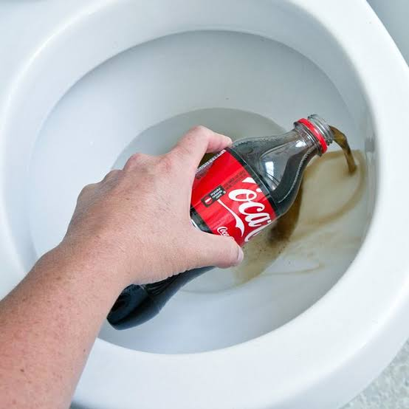****

# BIBLIOGRAPHY

**WEBSITES**

* [**www.wikipedia.com**](http://www.wikipedia.com)
* [**www.byjus.com**](http://www.byjus.com)
* [**www.googleimages.com**](http://www.googleimages.com)
* [**www.hsph.harvard.edu**](http://www.hsph.harvard.edu)

**BOOKS**

* NCERT Chemistry Book (Class-XII)